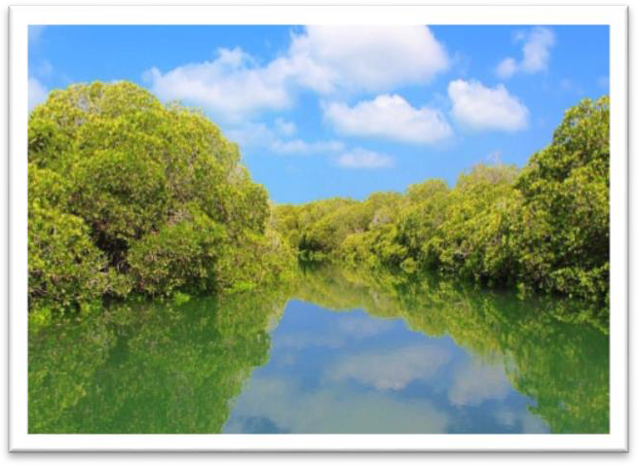
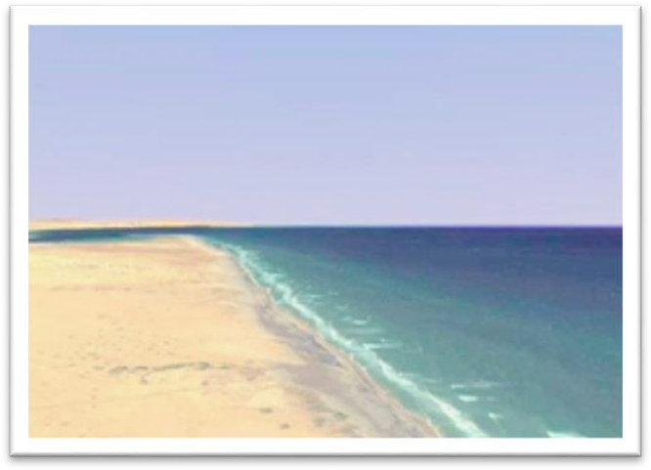
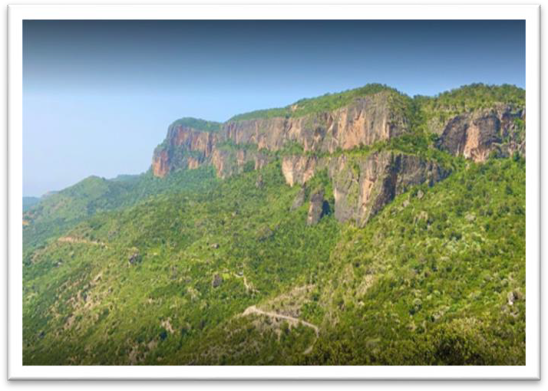
Tourism  High Mountains  High mountains are of one the most popular tourism sites in Somaliland. Ga’an Libah mountain, the name meaning “lion’s paw”, is a surprising example of the diversity of Somaliland’s landscape and wildlife. Her you can find wildlife including gazelles, kudu, baboons, hyena and leopards. Situated high on a high cliff it receives considerable rainfall and many parts are thick with trees and birdlife. The views from the edge, looking out over the plains below, are stunning, and the journey here is as interesting – a two to three hour drive through the desert passing nomads and settlements, where gazelles and warthogs flit between the thorn bushes.  Surad is highest peak in Somaliland at around 2670 ft. above the sea level. It is near Erigavo, the capital of Sanaag region. In this region, there is also the Daallo Mountain, one of the most beautiful national parks in Somaliland, which is rich with natural views. At the mountain's peak, one can see the sea as well as a tiny village called Mait about 60KM away. Sometimes the roar of leopards can be heard, for which the local  people have many stories to share. | Other popular mountains are located between Hudisa and Sheikh in the Sahil region of Somaliland. The ascent here from Berbera through the Sheikh bypass follows one of the most dramatic roads in Somaliland, starting from the village of Hudisa at the base of the Gollis range, then climbing some 700M over a 10KM series of switchbacks that offer fantastic views of the plains below.  Beaches  Berbera is a coastal city, which service as the biggest seaport for Somaliland, with its clean and unspoiled beaches at the Gulf of Aden. Swimming, snorkelling, fishing and scuba diving are some of the activities on offer. You will be surprised by how much fish there is with just 1% is used for consumption whilst the other 99% remain untouched.  Zeila has been identified as the historic city of the Avalitae. The town is known for its offshore island, coral reef and mangroves. Snorkelling and diving are still in its infancy yet the waters in Zeila are rich with turtles and dolphins.  Hotels and guesthouses, as a tourism subsector, are found in all big towns and cities throughout the country and closer to the tourism sites. Many hotels and guesthouses have benefited from the increasing number of visitor, often diaspora, and have adapted to meet the demands of international and local visitors. These have been complimented by good local knowledge of tourist sites. | The Sa’adadin islands is a group of islands off the northern coast of Somaliland. Covered by large forests it is home to hundreds of species of plants and animals in the region. The islands are only accessible by boat or sea transport since there are no bridges and airports on the island, but there are plans in the near future to improve transport infrastructure to connect the island to the mainland. The island would be an attractive investment to anyone who wants to make it more convenient, comfortable and luxurious in the future. Ebad is another island that shares the same features as Sa’adadin along the Red Sea.

Cement
The cement plant managed by the Berbera Cement Agency closed in 1991 due to the civil war. Since then Somaliland has imported all its cement needs. The cement factory in Berbera used to exploit limestone for the production of cement, in addition to having one of the world's largest deposits of gypsum-anhydrite near Berbera. Around 80 – 90% of the raw material for cement production is limestone, clayey raw material (clay, mudstone or shale) accounts for between 10 – 15% and the remaining 5% is gypsum or anhydrite. According to findings of several feasibility studies, raw material availability is in abundance for the plant to work for next 30 years. The only imported component for the functioning of the cement factory is fuel to run operations, which is an energy source that the country imports anyway for power generation at a national level. There are recommendations that coal deposits near Berbera could be used to power the cement factory when its operations are re-installed. The cement factory could produce 600 – 700 tons per day. The International Cement Review estimated the country’s cement consumption to be 100,000 tons per annum in 2000. It is reasonable to assume that annual consumption has increased over the past few years given the pace of urban residential construction fuelled by diaspora investment.

Salt
In Somaliland, the use of salt is limited to few requirements including table salt, basic food processing, leather tanning, and textile production due to the country’s lack of a meaningful industrial base. However, one area where salt is used in large proportions is “livestock-salting”.
Salt brine deposits (from evaporated seawater) in northwestern Somaliland near Zeila have been exploited for many years. Salt is produced from salt wells in Lughaya and by some tidal seawater capture in Berbera and other eastern parts of the country. Salt brine is produced using traditional methods of solar evaporation from seawater. The wind and sun evaporate the water from shallow pools, leaving the salt behind. It is usually harvested once a year when the salt reaches a specific thickness. This traditional method of salt production is not enough to utilize country’s potential and modern salt production techniques are needed to meet the potential salt demand in the domestic market as well as the markets in neighboring countries. Somaliland’s salt producing sites have fast, favorable salt production conditions including highly saline lagoon water, flat land, sun and wind, and has the potential to produce salt of very high quality not only for the domestic market but also for the Arab Peninsula. It is estimated that there are a few hundred participants involved in producing unprocessed sea salt along the Tokhoshi coast mostly for the local market.

Infrastructure
Infrastructure development is a policy priority for Somaliland’s path to sustainable recovery and reconstruction. The government fully understands this and has endeavored to create an enabling environment for investment and productive work based on strong and reliable infrastructure, which is a prerequisite for economic growth and development.

At present, the transport infrastructure of Somaliland comprises of about 780km of roads, one major seaport, two major airfields, and four airports, which have paved runways. There are no railways, pipelines or inland waterways. Since the late 1980s, there has been no major investment in the development of transport infrastructure and limited maintenance of the existing transport infrastructure. Road transport continues to be the principal mode of internal transport due to a lack of railway infrastructure and limited coastal shipping. Air transport has continued to play an important role in the small-scale industrial development in Somaliland.
Table 3: Number of ports in Somaliland
Port Class/Category | Number | Port Name/Location
Major | 1 | Berbera Port, Berbera City
Jetty | 1 | Las Qorey
Other minor ports | 2 | Mait, Hiis
Total | 4

