WHY INVEST IN SOMALILAND?

SECURITY AND TRANSPARENCY
Somaliland is Strategic positioned in the center of the Horn of Africa and along the Gulf of Aden near the entrance to the Bab al-Mandeb and route through Red Sea and Suez Canal, a
Major sea-lane through with one-third of the world's shipping passes.

STRATEGIC LOCATION

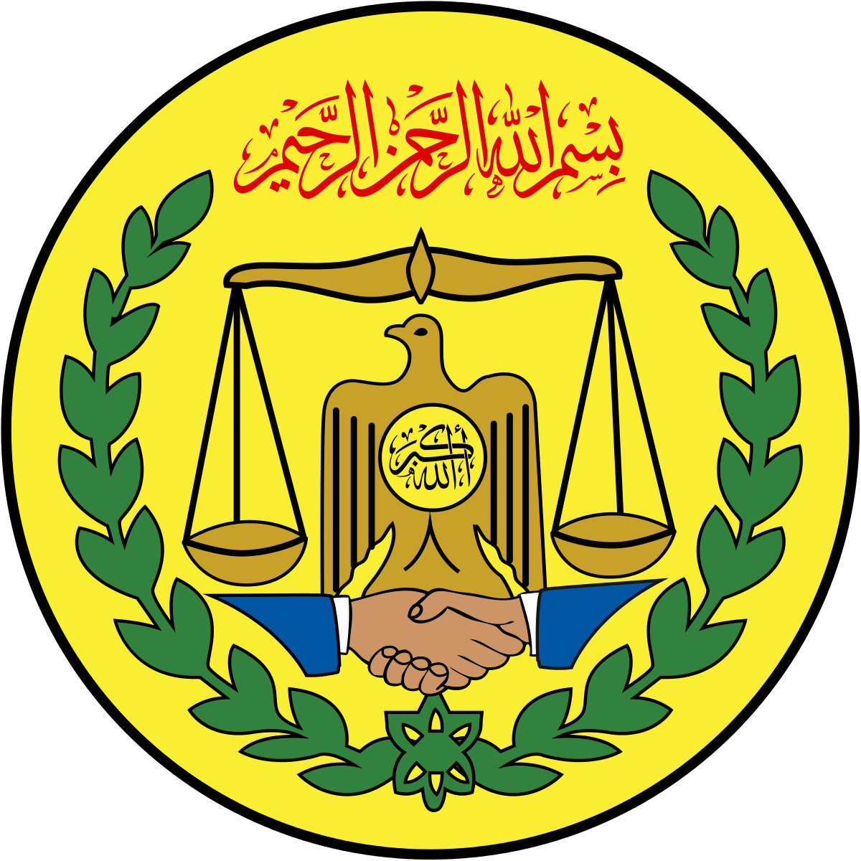MINISTRY OF INVESTMENT PROMOTION
وزارة تــــــنمية االســــــــــتـثـمـار
WASAARADDA HORUMARINTA MAALGASHIGA

OPEN MARKET
The Economic System of Somaliland is a free market system based on supply and demand with liFle or no Government control, Somaliland Enjoys open Market polic ie s tha t ar e de sig ne d t o e lim ina t e discrimination against foreign investors, business projects, Investments and Financial transactions. To promote new opportunities and Innovation.

RICH RAW
Somaliland has witnessed a great deal of progress over the last 30 years of self-governance. Peace and stability has been restored through the eﬀorts of the people of Somaliland. Democratic systems have been established and have continued to evolve a@er ﬁve suc c e ssf ul e le c ti ons at the pre side n ti al, parliamentary and local government levels.
MATERIALS BASE
Somaliland is rich in mineral resources deposits of many kinds of gemstones like Emerald, Sapphire, Ruby, Aquamarine, Opal and any kind of Garnet. There are also plenty of other minerals in Somaliland such as industrial minerals like iron ore, Titanium, Aluminium, Tungsten, Tin, Galena and other rare earth metals like Columbite Tantalite, Molybdenum and many other rare minerals which are only found few places in the world.

WHY INVEST IN SOMALILAND ?

MINISTRY OF INVESTMENT PROMOTION
وزارة تــــــنمية االســــــــــتـثـمـار
WASAARADDA HORUMARINTA MAALGASHIGA
PROFIT & IMPORT TAX EXEMPTION

Investors will enjoy a 100% three to ﬁve year’s tax holiday on proﬁts and 100% custom exemption on imported raw materials, machinery, equipment, installation and any other ouYits, supplies and components imported for production purposes are exempted from import custom duties.

LAND OWNERSHIP AND PROPERTY LEASING
Both foreigners and Somalilanders are freely able to purchase and sell property as the y w ish. Land ownership rights are strongly upheld within Somaliland.

PUBLIC PRIVATE PARTNERSHIP ( PPP)
Somaliland Government stands for establishing viable Public Private Partnerships (PPPs) to address large scale infrastructure development that are beyond the ﬁnancing capacities of the Government

GUARANTEES AGAINST EXPROPRIATION
Investments that have been properly registered with and approved by the Board may not be expropriated unless there is no other method by which the government can safeguard the “public interest.

